Project Solution

First we will install kubectl and minikube for this project.

Please find the steps below.

Install kubectl binary with curl on Linux

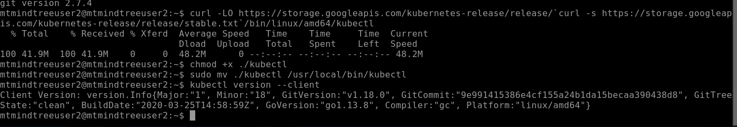

Now we will be installing minikube

Minikube as the name suggests the cluster will be having only 1 node.

Install Minikube via direct download

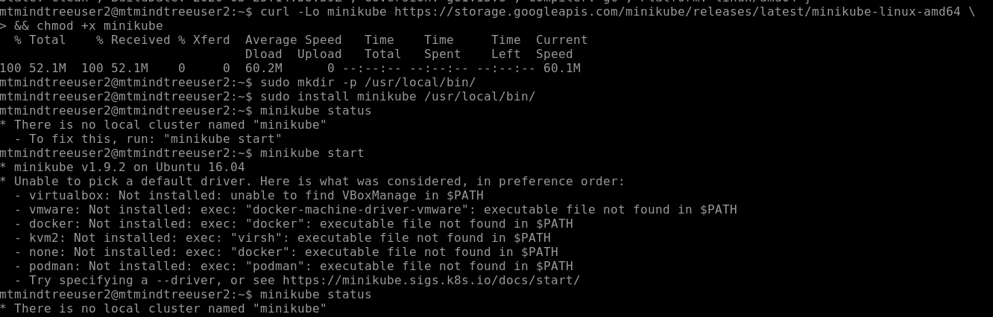

Now we will be installing docker as it is not installed.

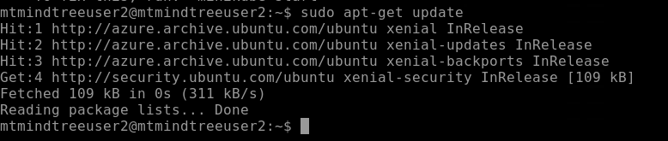

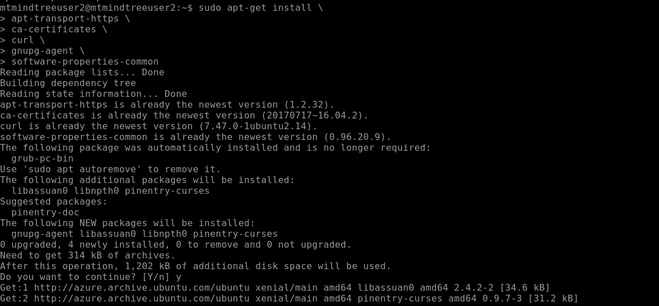

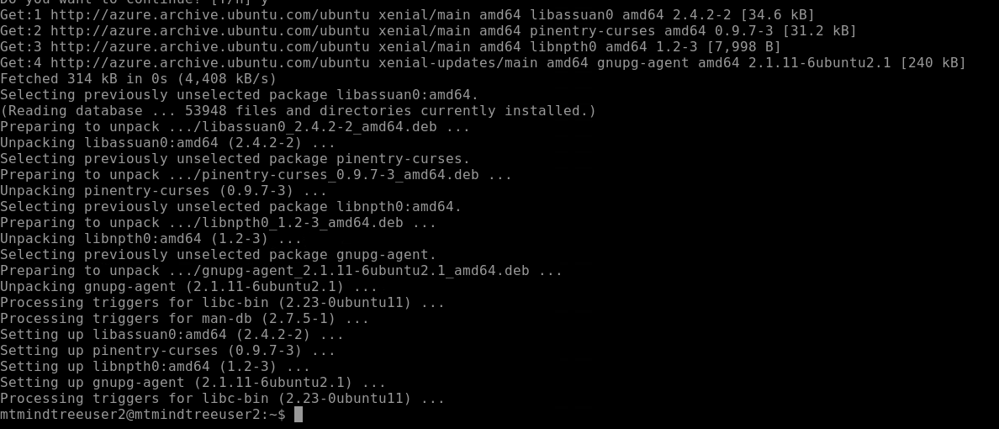

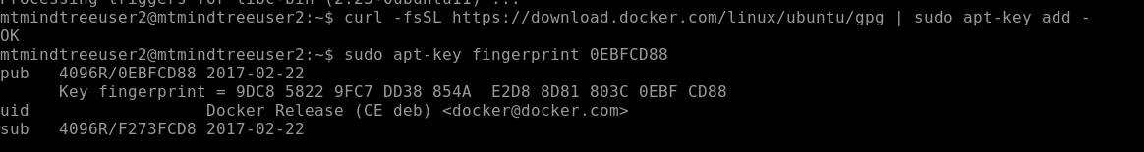

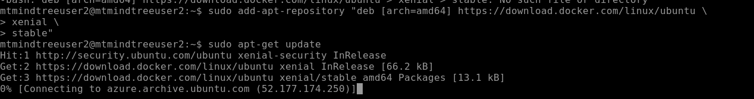

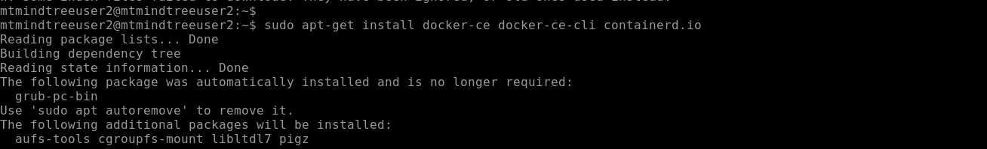

To check whether the docker is installed correctly or not



